**MAXIMIZING REVENUE STREAMS FOR TAXI CAB DRIVERS THROUGH PAYMENT TYPE ANALYSIS**

**PROBLEM STATEMENT**

In the fast-paced taxi booking sector, making the most of revenue is essential for long-term success and driver happiness. Our goal is to use data-driven insights to **maximize revenue streams for taxi drivers**. Our research aims to determine whether payment methods have an impact on fare pricing by focusing on the relationship between payment type and fare amount.

**OBJECTIVE**

This project's main goal is to perform a hypothesis testing to examine the **relationship between the total fare and the method of payment**. We use descriptive statistics to extract useful information which we can use to optimize the pricing strategies for drivers and boost their earnings. In particular, we want to find out if there is a big difference in the fares for those who pay with credit cards versus those who pay with cash.

**RESEARCH QUESTION**

Is there a relationship between total fare amount and payment type and can we nudge customers towards payment methods that generate higher revenue for drivers, without negatively impacting customer experience?

**ANALYSIS AND FINDINGS:**

**JOURNEY INSIGHTS:**

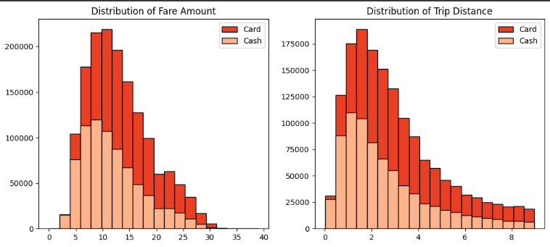 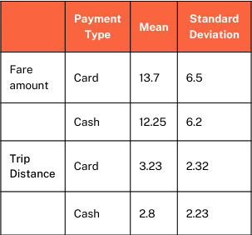

**Observations from the "Distribution of Fare Amount":**

**Card Dominance at higher fare:**

A larger proportion of trips (roughly $5 to $30) paid for with a card have higher fare amounts compared to those paid with cash

At the very low end of the fare spectrum (below $5), cash payments appear to be more frequent than card payments. This could be due to passengers preferring cash for very short or inexpensive trips.

**Observations from the "Distribution of Trip Distance":**

**Card Dominance for longer journey:**

Similar to the fare amount, cards are generally higher than cash across a significant range of trip distances (roughly 2 to 7 units of distance). This implies that trips that are paid with cards tend to cover longer distances on average.

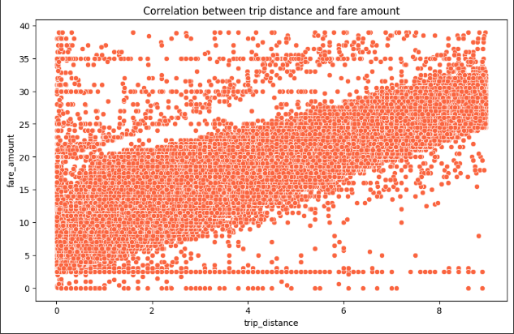

**Correlation between Distance and Fare:** The fact that both fare amount and trip distance show similar trends when broken down by payment method strongly suggests a **positive** **correlation** between trip distance and fare amount, which is expected. Longer trips naturally tend to cost more.

**2. PREFERENCE OF PAYMENT TYPES**

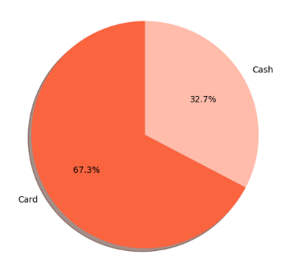

The proportion of customers paying with cards is significantly higher than those paying with cash, with card payments accounting for 67.5% of all transactions compared to cash payments at 32.5%.

Card payments are generally more efficient for drivers in terms of handling money and reducing the risk of carrying large amounts of cash.

The high preference for cards likely reflects the increasing trend towards cashless transactions and the convenience they offer.

**Passenger Count Analysis:**

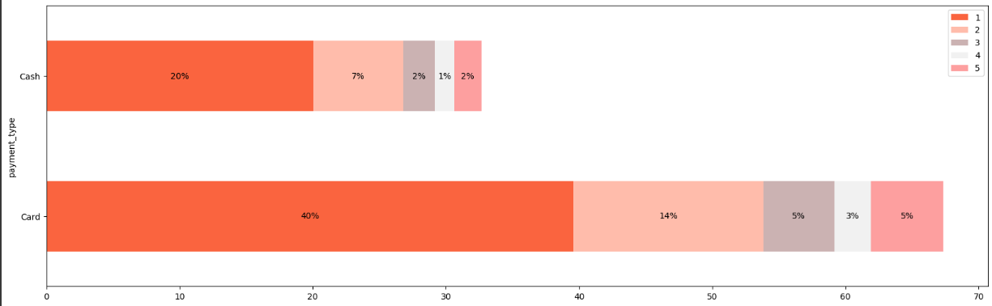

The largest segment for both payment types is the "1 passenger" category. However, this segment is significantly larger for card payments (around 40%) compared to cash payments (around 20%). This suggests that individuals traveling alone are much more likely to pay with a card.

As the number of passengers increases (2, 3, 4, and 5), the proportion of trips paid with a card generally remains higher than those paid with cash. For instance, the percentage of card trips with 2 passengers (around 14%) is double that of cash trips with 2 passengers (around 7%). This trend continues, indicating that when more people are traveling together, they tend to favour card payments.

The segments for 4 and 5 passengers are noticeably larger for card payments compared to cash. This could be due to the convenience of splitting fares or simply a preference for electronic transactions when dealing with larger amounts associated with bigger groups.

**HYPOTHESIS TESTING:**

**Null hypothesis:** There is no difference in average fare between customers who use credit cards and customers who use cash.

**Alternative hypothesis:** There is a difference in average fare between customers who use credit cards and customers who use cash

With a T-statistic of 165.5 and a P-value of less than 0.05, we reject the null hypothesis, suggesting that there is indeed a significant difference in average fare between the two payment methods

A very large absolute t-statistic (like 165.5) indicates a substantial difference between the sample means. It suggests that the observed difference is much larger than what would be expected by random chance if the null hypothesis were true.

**RECOMMENDATIONS:**

* **Encourage card payments for higher driver revenue** through subtle prompts within the booking app that highlight the speed or convenience of card payments.
* For example, making the card payment option the default or pre-selected choice (while still offering cash).
* **Incentivize credit card use with discounts i**s a practical strategy to nudge customers towards card payments. Also offering very minor bonus points or perks for using card payments.
* Provide seamless and secure credit card payment options to enhance customer convenience and encourage adoption of this preferred payment method.
* Ensure taxi drivers are well-trained and confident in handling digital payments. Address any concerns they might have.

**We also need to keep in mind that addressing Cash Users is important too**. Given that a significant portion still prefers cash, completely eliminating it could negatively impact a substantial customer segment. We can continue to offer cash payments as a viable option.

**IMPORTANT CONSIDERATIONS:**

* **Transaction Fees:** Drivers (or the taxi service they operate under) might incur transaction fees for credit card payments. It's crucial to ensure that the benefits outweigh these costs. The fee structure needs to be transparent and manageable.
* **Access to Funds:** The time it takes for the funds from digital transactions to become available to the driver's account is important. Quick and reliable pay-outs are essential.
* **Reliability of Technology:** Drivers need reliable POS devices or payment app functionality. Technical issues can lead to frustration for both drivers and passengers.